Fn Intwerface

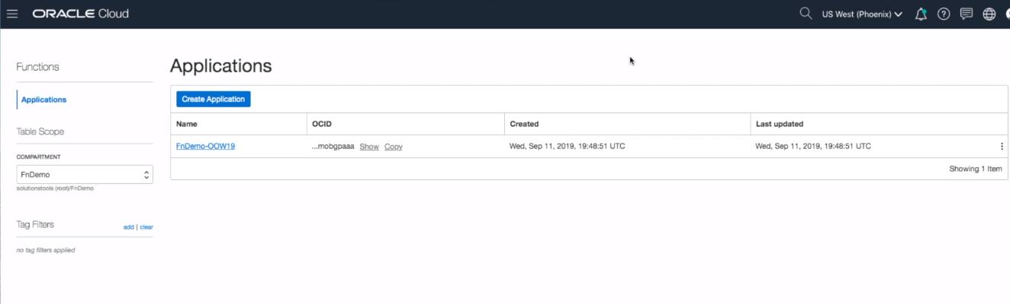

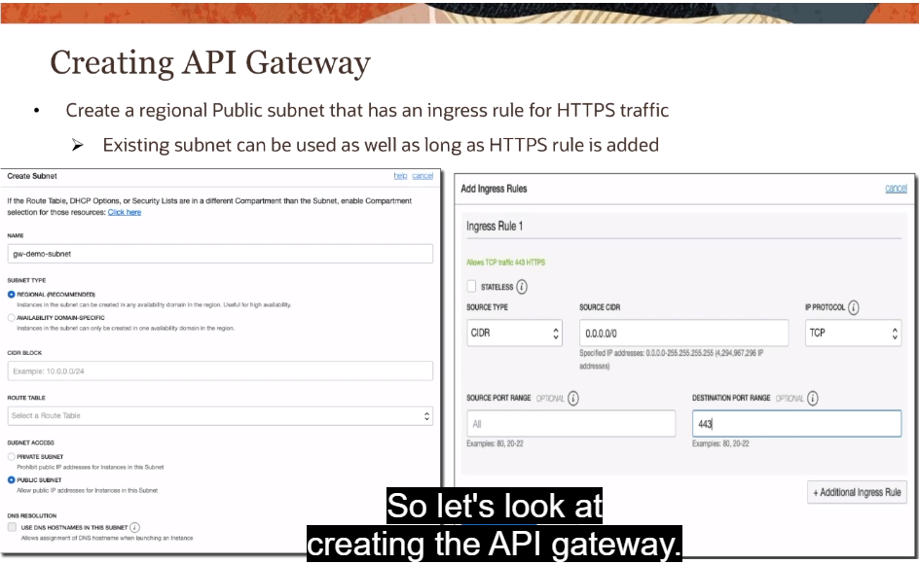

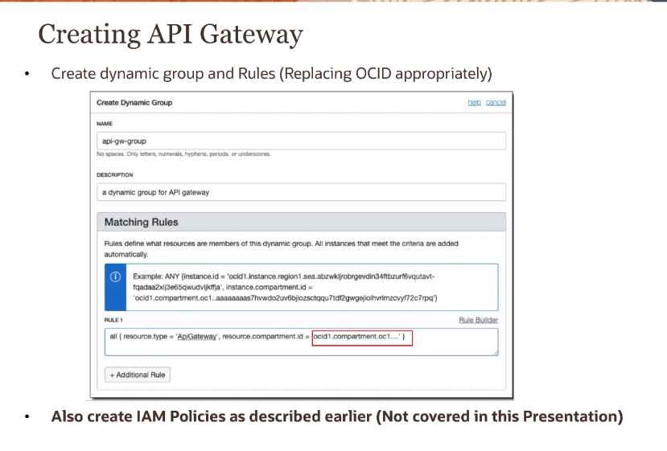

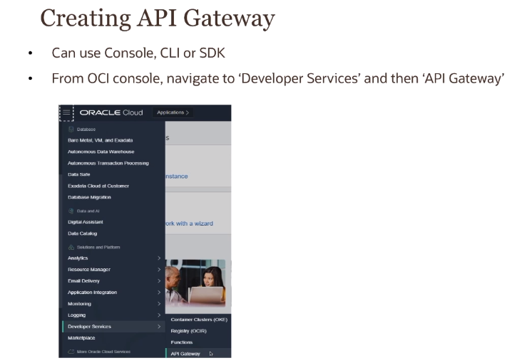

\ 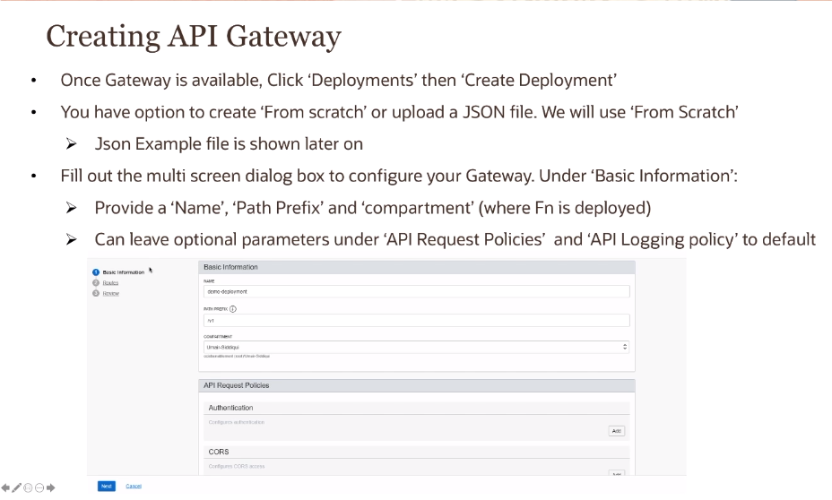

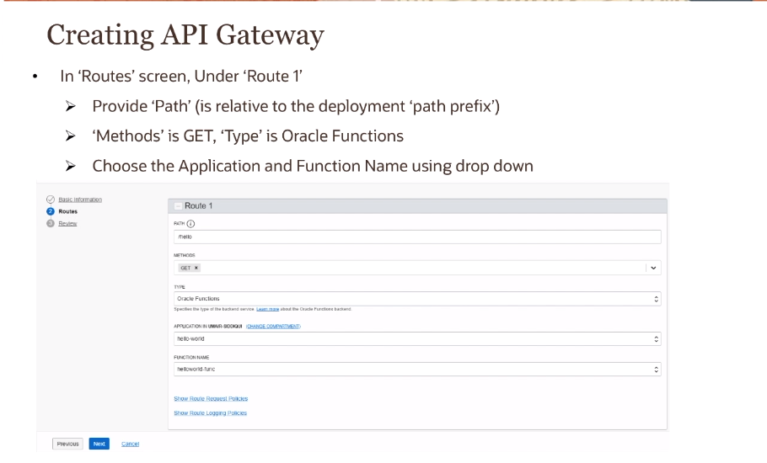

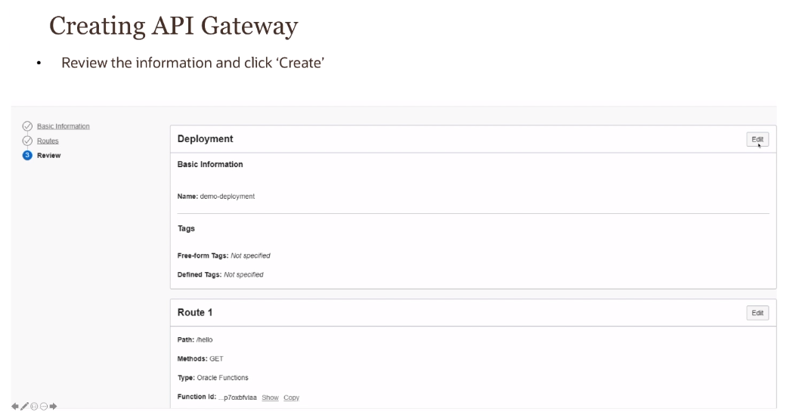

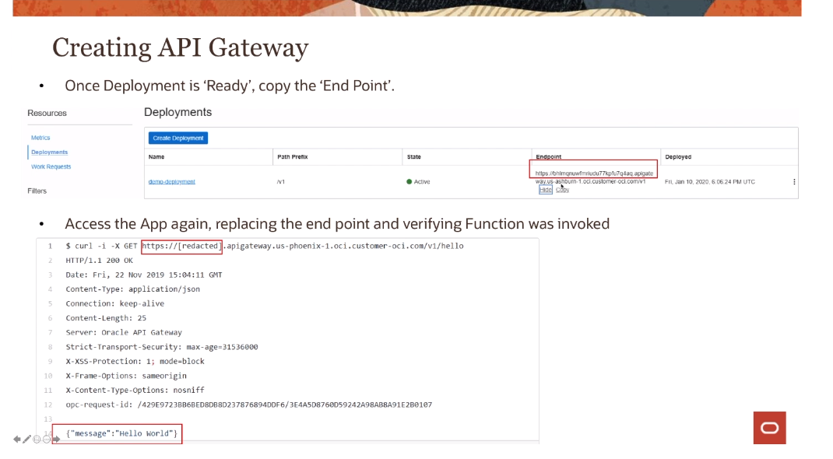

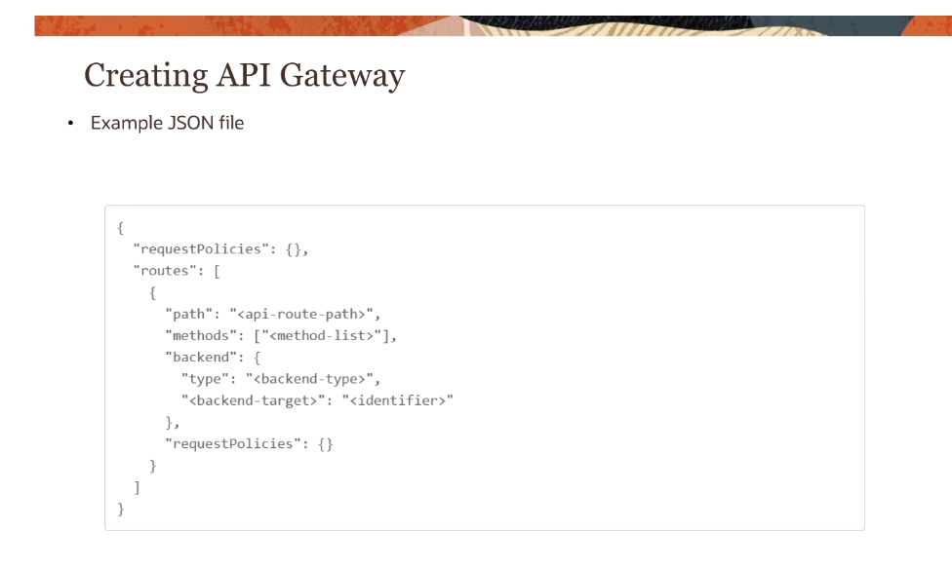

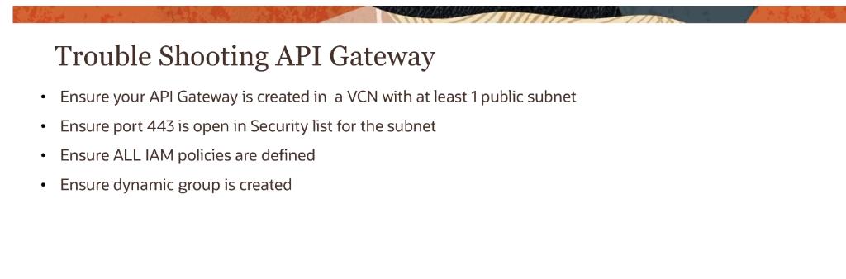

**Resource manager**

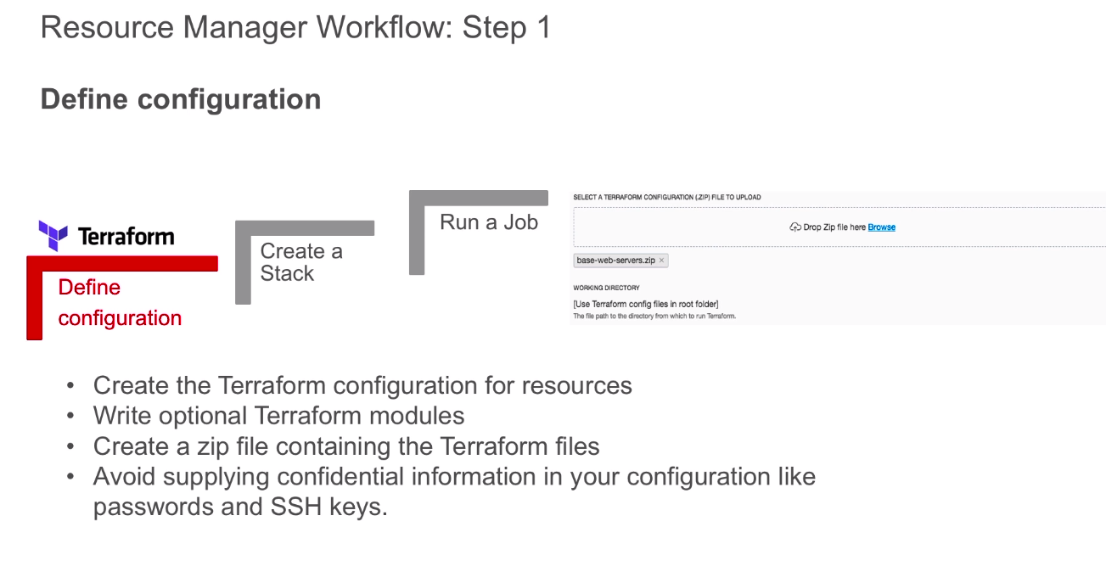

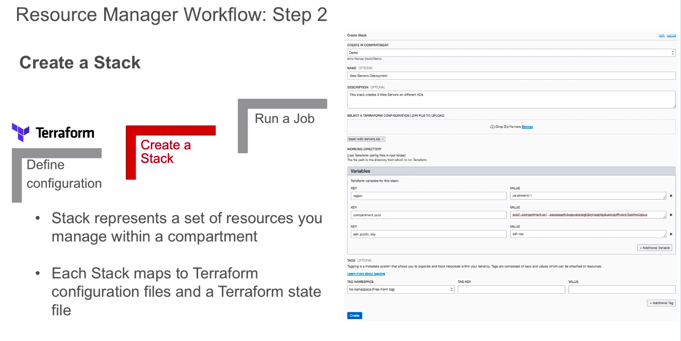

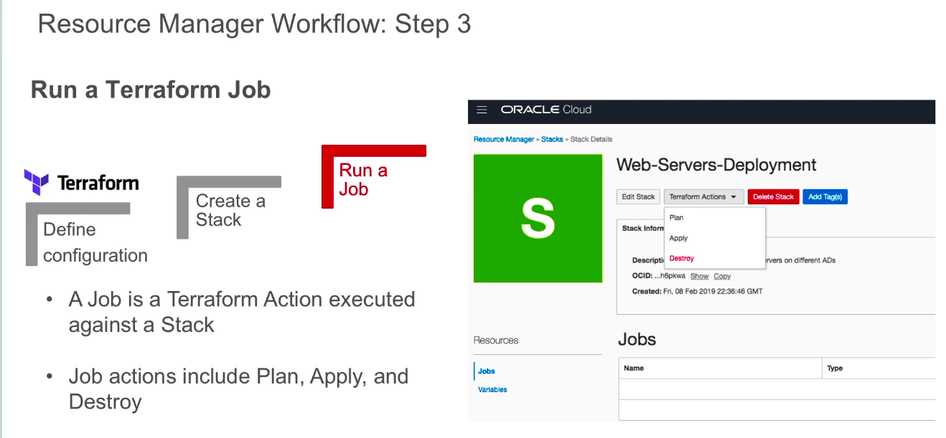

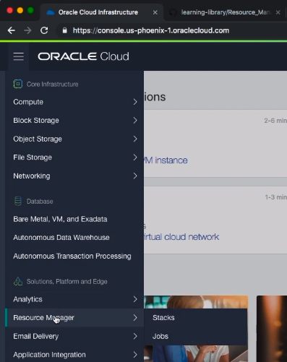

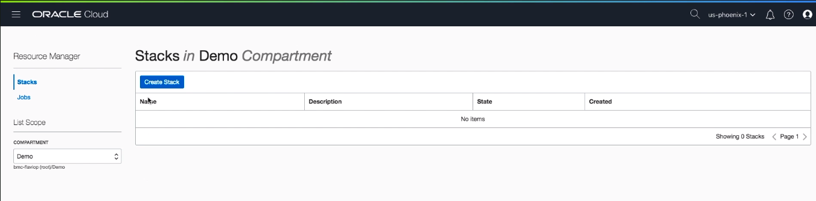

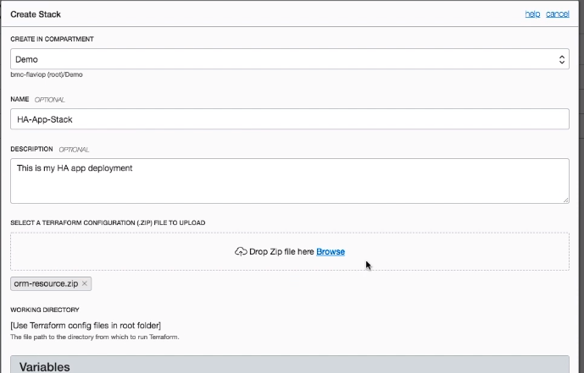

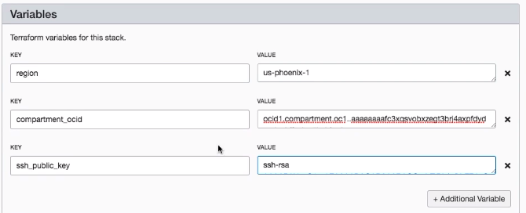

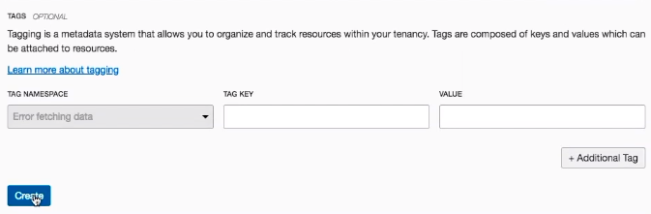

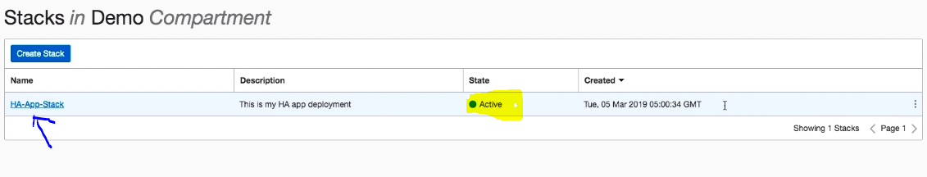

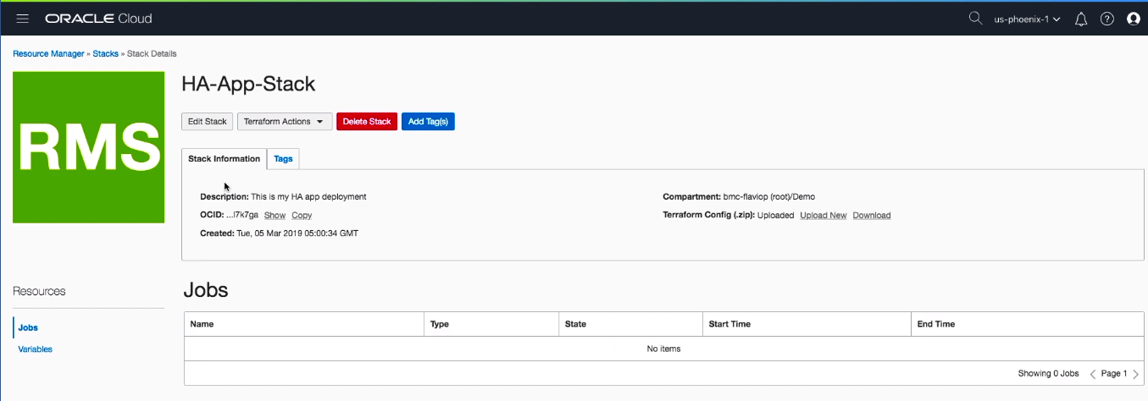

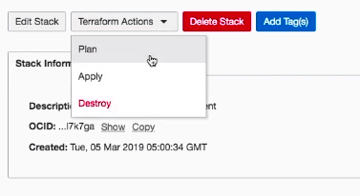

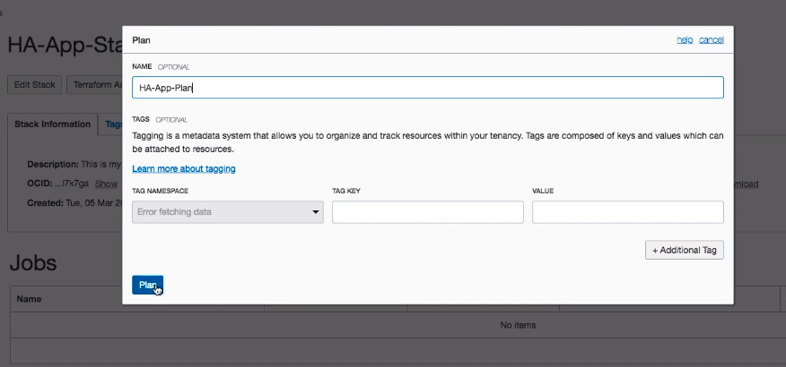

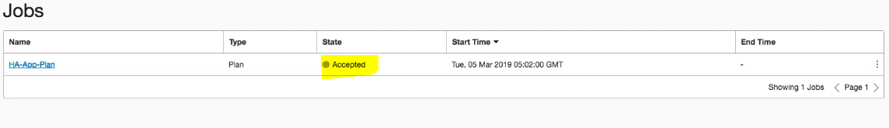

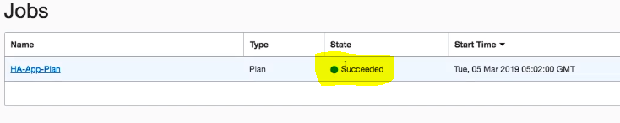

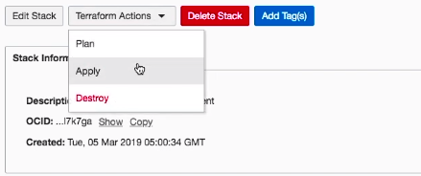

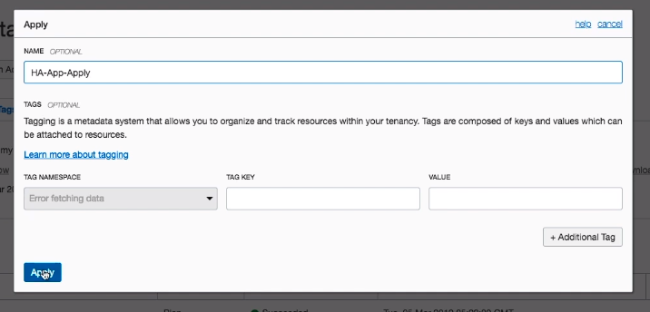

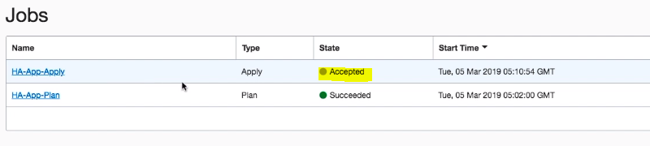

After this the compute instances (web servers), VCN and load balancers are created autpmatically. You can check that in console.

You can also destroy it after this.

OKE

There are three ways to Run Kubernetes on OCI.

1. We have to set up our own kubernetes cluster using Infrastructure such as compute, the networking, and the storage services from OCI. And then installing you own container runtime which can be docker and on the top of that installing our own orchetration system like kubernetes, Swarm, Mesos.

DIY : Do it yourself.

This is called DIY model because the core infrastructure components is provided but to run its all at our end.

1. Second way is instead of creating or installing all of the components yourselves, there is a quickstart available on terraform(OSS terraform installer on Github). It is managed by the oracle team and they regularly manage it. Its kind of quickstart experience. It quickly creates a kubernetes clusyer on the top of the OCI. This is partly DIY as they give the Terraform to set up the Kubernetes cluster but at the end we are managing the cluster ourselves.
2. Container Engine for Kubernetes(OKE), This is where the managed kubernetes Services comes into the picture. We call it OCI Container engine for Kubernetes. It is a managed service that allows us to create the Kubernetes cluster within few minutes. For then onwards the master components are managed by the service itself.. We are only responsible for our own worker/compute Nodes.

Terraform Kubernets Installer for OCI.

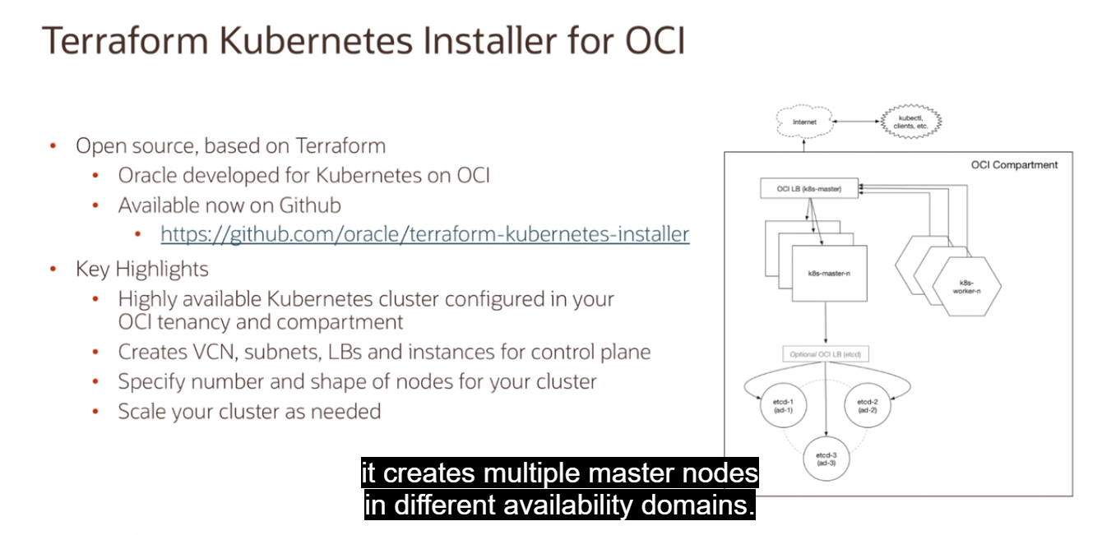

OKE

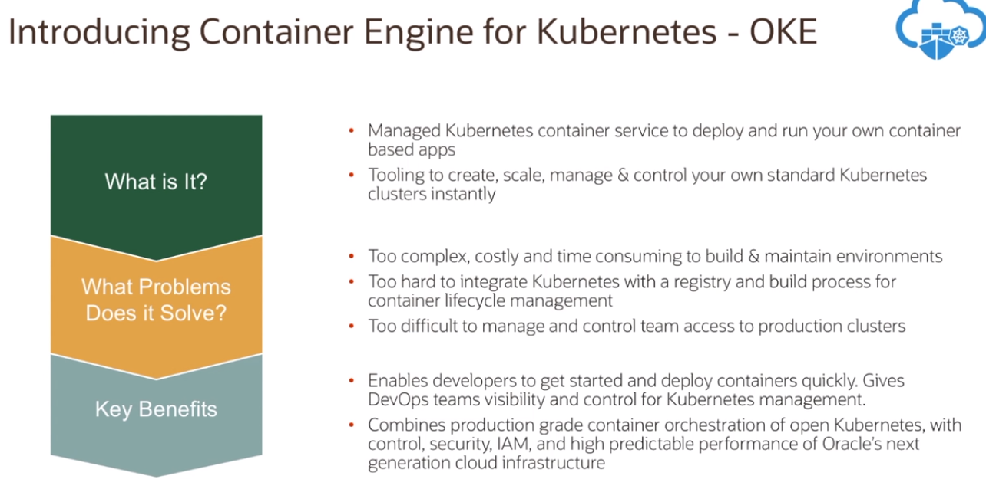

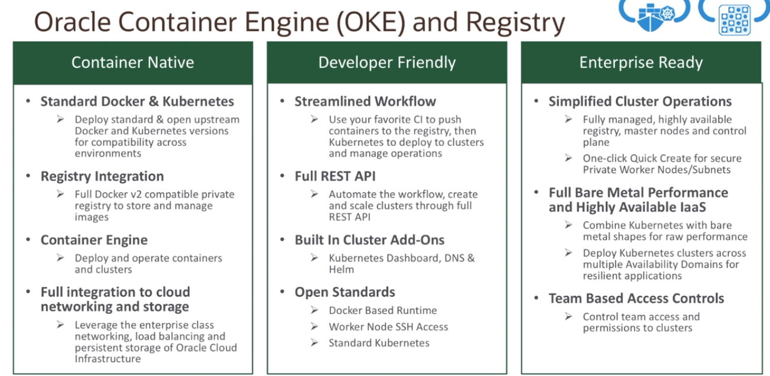

Craete a cluster in OCI

Pre-requisite

1. By default, there is a limit of three clusters per OCI region if you have monthly universal credits or if you are using the Pay-as-you-go promo account.
2. You also need to have some quota on the compute instance size because as you launch you kubernetes cluster and if you wanna launch any additional worker nodes you need to have some kind of quota available for your worker nodes.
3. For the IM policy perspective, like every other service the OKE service is also very tightly integrated with Identity and access Management. So, before we actually create the cluster there is a specific policy that needs to be created within the root compartment of your tenancy where you allow the service OKE to manage the resources on your behalf in your tenancy.

* Allow service OKE to manage all-resources in tenancy needs to be put in the root compartment, and you just needs to allow the service to manage all resources in tenancy.

These are the policies you need to have before craeting the cluster.

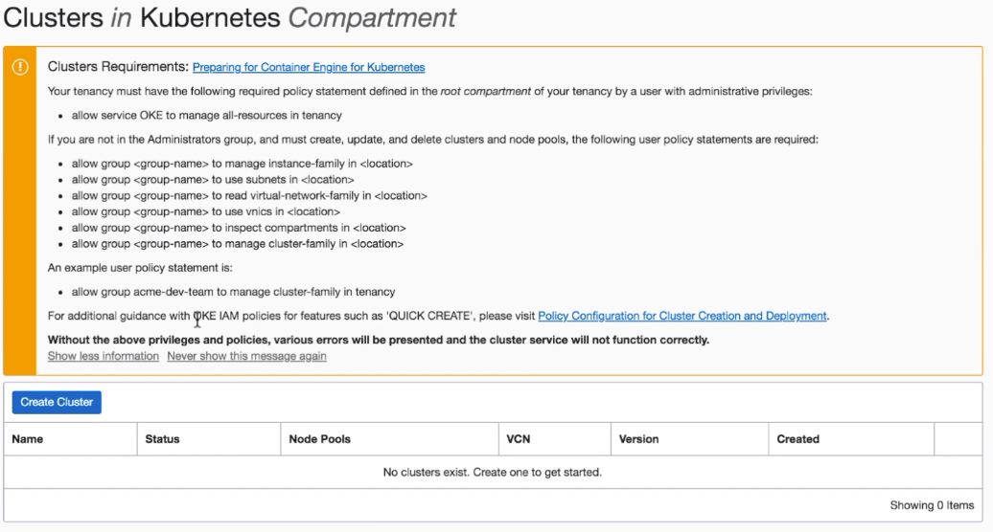

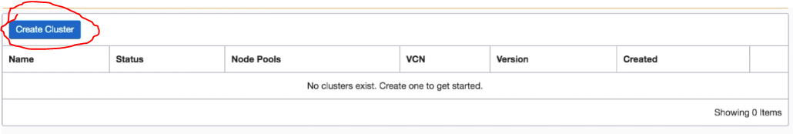

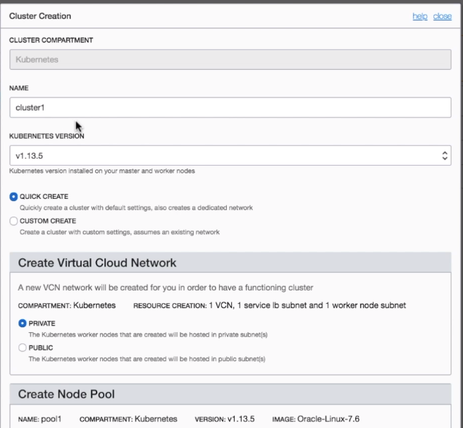

For Accessing the dashboard:

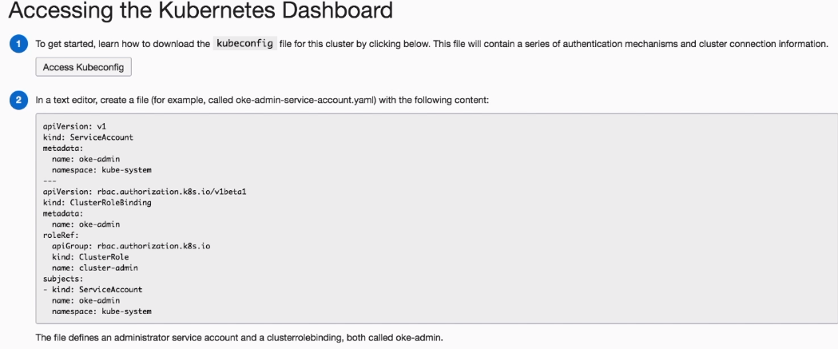

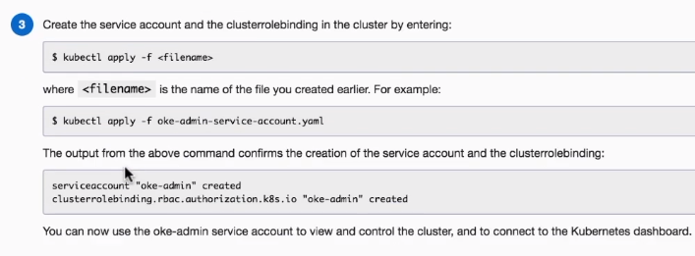

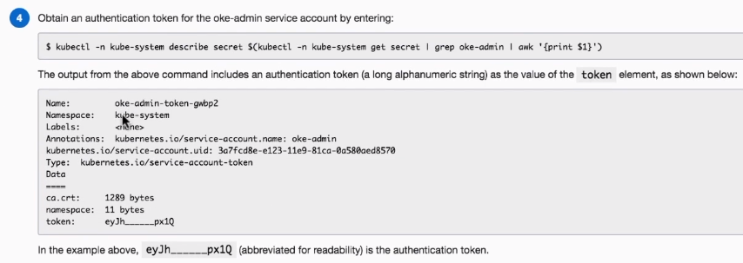

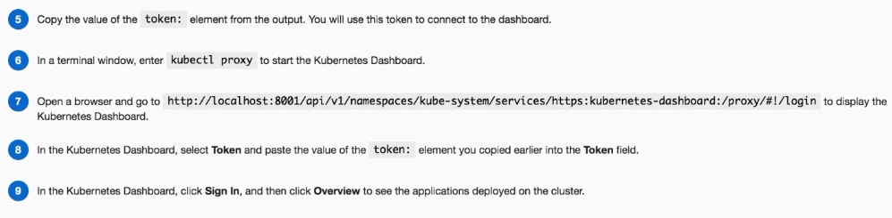

Now, you can see the dashboard like this

